Embargo: June 23th, 2021 at 9:00am Taipei time

D-Link Reveals Latest Connectivity Innovations at
Mobile World Congress 2021
D-Link’s newest launches for businesses and consumers are set to pave the way for the new era of networking caused by the pandemic
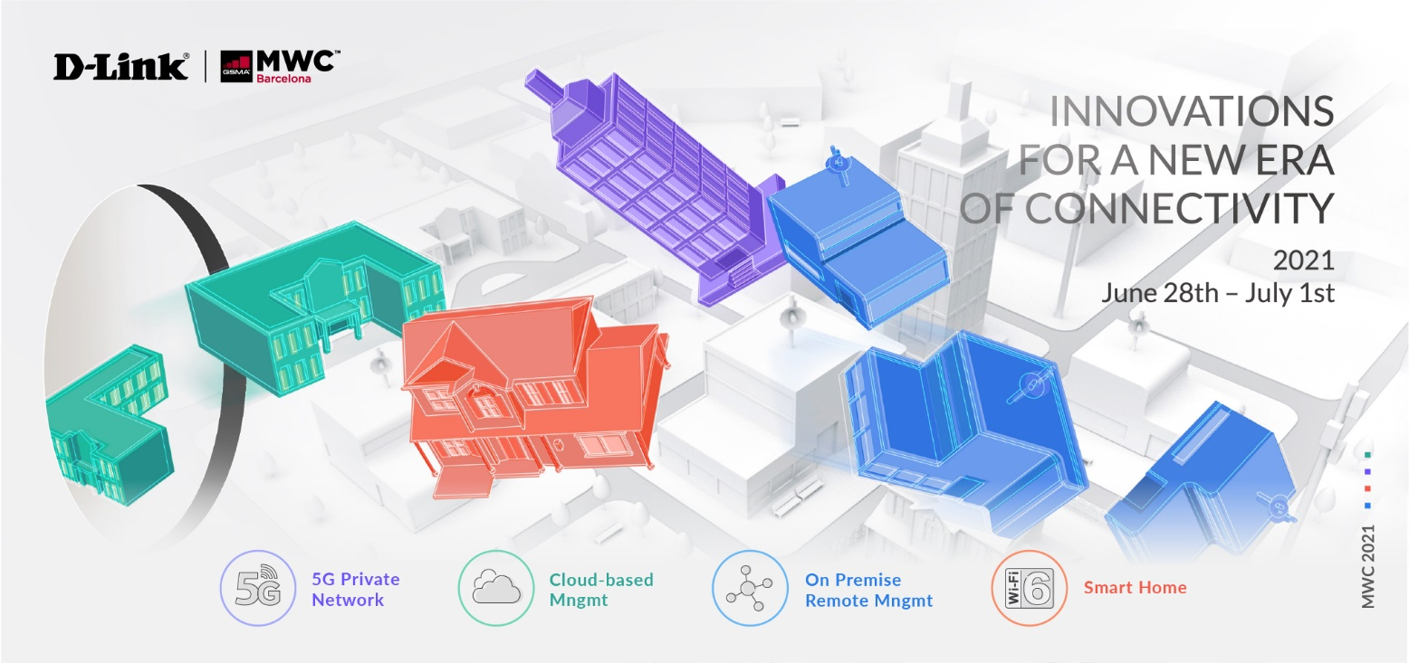

[MWC: June 2021] – D-Link, a global leader in networking technologies, will unveil its latest networking technologies engineered for enterprise 5G private networks, cloud-managed campus networks, on-premise SMB networks, and smart home networks at this year’s Mobile World Congress (MWC), in Barcelona, Spain.

All over the world, the pandemic and continued ‘stay-at-home culture’ has resulted in a natural reliance on technology and being connected, and created an overwhelming rise in decentralized workforces. Business owners have had to accept the impact this will have on the future of work, re-evaluate their existing network infrastructure, and adapt to the decentralization of the workplace by leveraging new technologies to help them optimize efficiency and productivity.

What’s more, the new global mobile workforce also demands advanced technologies to enable remote working. With that in mind, D-Link’s latest 5G Private Network, Nuclias Connect, Nuclias Cloud, and Smart Home solutions are specifically designed to support this new era of connectivity.

5G Private Networks
Traditional, fixed broadband can be expensive and challenging for large enterprises to implement, especially in suburban or rural areas. 5G Fixed Wireless Access (FWA) delivers the high bandwidth and low latency connection that enterprises need to operate remotely while at a lower cost for internet service providers. At MWC, D-Link will present its latest technologies for enterprise 5G private networks, including a new 5G gateway that delivers robust security and high reliability to address critical wireless communication requirements for industrial applications.

Nuclias Connect
D-Link’s on-premise network management is private, highly secure, and builds into a business’ existing IT infrastructure to allow management and complete oversight. With Nuclias Connect and its wide range of compatible devices, including Wi-Fi 6 access points, smart switches, and a new network controller hub, SMBs with remote locations can build and manage the surveillance network they require to optimize productivity. What’s more, to lend more support to the new ways of working, Nuclias Connect also comes fully equipped with high scalability, easy multi-site management, and advanced analytics.

Nuclias Cloud
Businesses are still facing new challenges that have emerged because of the pandemic, including budget constraints, lack of IT resources, inadequate network security, and decreased productivity. With these obstacles in mind, Nuclias Cloud offers a cost-effective solution that combats these head-on – and allows for cloud-managed networks to be quickly deployed and easily maintained, minimizing costs and maximizing resources. Nuclias Cloud provides secure company network access, unlimited scalability, zero touch deployment, as well as role and privilege-based access control. D-Link will be introducing new enhanced features and compatible devices – such as Wi-Fi 6 access points and a new cloud-managed SD-WAN Gateway.

Smart Home
Demand for faster, higher capacity connectivity has increased exponentially around the world as bandwidth-intensive applications become increasingly prevalent at home. D-Link’s range of smart home solutions leverages cutting-edge AI, Wi-Fi 6, 5G, and Mesh technologies to provide the powerful speed and capabilities that standard wired broadband connections cannot offer. At MWC, D-Link will be displaying the latest smart surveillance cameras, a Wi-Fi 6 USB Adapter, the AI Series, and the new 5G/LTE Outdoor CPE.

For more information, please visit the D-Link MWC event website.

###

END OF ANNOUNCEMENT

About D-Link
D-Link is a global leader in connecting people, businesses, and cities with our computer networking solutions and technology. Our innovative products and services meet the needs of digital home consumers, small to medium sized businesses, enterprise environments, and service providers. D-Link implements and supports unified network solutions that integrate capabilities in switching, wireless, broadband, IP surveillance, and cloud-based network management. An award-winning designer, developer, and manufacturer for over 30 years, D-Link has grown from a group of friends in Taiwan into a global brand with over 2,000 employees in 60 countries.

D-Link Corporation PR Contact:
Angela Lo
Angela.Lo@dlinkcorp.com +886-2-6600-0123 #6652

