Embargo: June 29th, 2021 at 3:00PM Taipei Time

D-Link Nuclias Cloud Solutions Boost Business Productivity with Simple, Scalable Management at MWC 2021
Nuclias cloud-managed network solution facilitates post-pandemic workforces to optimize business operations

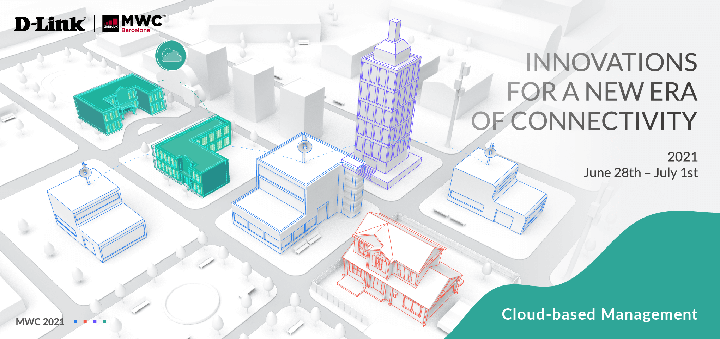

[MWC: June 2021] D-Link, a global leader in network technology solutions, has introduced their latest Cloud-enabled SD-WAN Gateway and mobile apps to their Nuclias Cloud network management solution at Mobile World Congress in Barcelona, Spain. Amidst the pandemic, many businesses struggle to maintain workforce productivity while transitioning to virtual work environments. The obstacles include cost constraints, lack of IT resources for network management, security concerns, application access, and social distancing regulations. D-Link’s Nuclias Cloud Networking Solution helps businesses resolve these issues and build the infrastructure needed to support a largely remote workforce while reducing cost, maximizing resources, and alleviating daily network management challenges. Small businesses owners are provided with cost-effective cloud networks that are quickly deployed and easily maintained, and track and trace features through the cloud-enabled access points improve visibility and business efficiency.

D-Link offers a range of Nuclias Cloud-managed devices, including the SD-WAN Gateway, Switches, and Access Points that optimize business productivity. This year’s newly announced Nuclias Cloud Wi-Fi 6 access points benefit businesses by delivering more network capacity, reduced congestion, low latency, and massive data throughput. Their newest DBG-2000 Nuclias Cloud SD-WAN Gateway offers centralized control to securely and intelligently manage traffic. Its site-to-site VPN allows workforces to access the company’s network via a secure connection. Professional-grade protection and privacy are provided thanks to a powerful network firewall, the Intrusion Prevention System that shields the network from cyber attacks, and Dynamic Content Filtering for categorization and control of accessible sites to safeguard against malicious websites. The DBG-2000 also features simple policy management for users to execute policies across the network for greater consistency and protection.

D-Link has also expanded their 3rd party partnerships for features such as Covid track and trace that meets law requirements to collect contact information and ease the process of re-opening offices, restaurants, etc. Additionally, Nuclias Cloud iOS and Android mobile apps will be available later this year for administrators to monitor networks anytime, anywhere. Biometric login and two-factor authentication provide account access security, and QR code scanning provides for quick setup. Nuclias Cloud features intuitive dashboard management and zero touch provisioning, allowing for easy deployment and management of networks without the need for highly trained IT personnel. Unlimited scalability is ensured, as companies can add devices to the network as their business grows. Nuclias Cloud also provides role and privilege-based access control, as well as real-time traffic report monitoring and analysis for identifying and resolving network issues for the highest quality connectivity.

For more information, please visit the D-Link MWC event website.

###

END OF ANNOUNCEMENT

About D-Link
D-Link is a global leader in connecting people, businesses, and cities with our computer networking solutions and technology. Our innovative products and services meet the needs of digital home consumers, small to medium sized businesses, enterprise environments, and service providers. D-Link implements and supports unified network solutions that integrate capabilities in switching, wireless, broadband, IP surveillance, and cloud-based network management. An award-winning designer, developer, and manufacturer for over 30 years, D-Link has grown from a group of friends in Taiwan into a global brand with over 2,000 employees in 60 countries.

D-Link Corporation PR Contact:
Angela Lo
Angela.Lo@dlinkcorp.com +886-2-6600-0123 #6652

