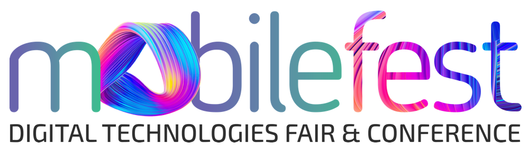
We aim to be one of the the leading technology shows,, generating ongoing global business opportunities for technology service providers.
Name: Mobilefest Digital Technologies Fair & Conference
Date: 11-13 November 2021
Type: Onsite & Online
Objective: Gathering technology providers, system integrators, entrepreneurs and developers together with corporate buyers, executives and investors to create new business, partnership and sales opportunities.
Venue: İstanbul Kongre Merkezi, İstanbul, Turkey.
Visitor Profile: B2B Visitors; Hosted Buyers, C-Level Executives (CEO, CTO, CIO, CMO), directors, managers, investors.
Exhibitor Profile: Technology and Service providers, ICT Companies, system integrators, developers, entrepreneurs.
Scope: 5G & Telecommunications, IoT, Cloud Computing, Data & Analytics, AI, Cyber Security, Autonomus and Electric Vehicles, Robotics, CRM/ERP, Business Solutions and other vertical technologies (Fintech, Education, Health, Tourism etc)

Grow Your Business With Mobilefest
Gather with global buyers and decision makers in Hybrid (Onsite & Online) model of Mobilefest and create new business, partnership and sales opportunities
- Future Technologies,
- 2 days of conference program,
- 3 days of sectoral course and workshops,
- B2B meetings and buyer delegations
Mobilefest is on its way to become the largest and most influential technology fair in Eurasia.
Take your place in Mobilefest!

Event Website: https://www.mobilefest.net/en
Contact for details:
Mrs. Serap Demir Seyrek
Business Development Executive
E: serap.seyrek@expohis.com

