The Model number is a newly designed mobile signal repeater with intelligent functions, it’s main purpose is the help the end user to enhance the indoor cellular coverage. Except the traditional MGC, AGC function, the repeater has also introduced many other function, such as the Input and Output Signal Strength indicators, Antenna isolation detection, UL sleep, Smart etc to make sure the repeater is working in linear status and will not affect the BTS.

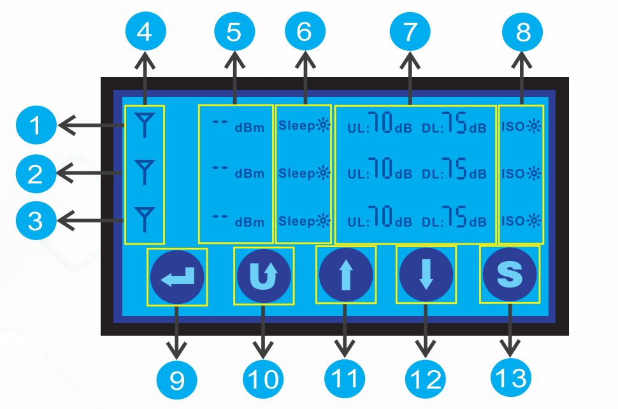

- The line shows the working status of system 1.
- The line shows the working status of system 2.
- The line shows the working status of system 3.
- 5 bars of the output signal strength indicator, which shows you the maximum output power of the repeater. Each signal bar represents 5dB.
- The specific value of the input signal strength measured in dBm, tell us the exact input signal level.
- Uplink sleep Mode. The uplink of the repeater is in standby mode when there is no call or data transmission. It will activate immediately when a call a data session is initiated.
- Shows the UL & DL maximum gain.
- Antenna Isolation Detection. When first power on the repeater, the repeater will detect the oscillation automatically between the outdoor antenna and indoor antenna.
- Enter for selection or confirm the settings.
- Back to the previous page or cancel the settings.
- Increase the gain
- Decrease the gain
- Smart function that repeater could set the gain automatically to prevent the Alarm. Press this icon to turn ON or turn OFF this function.

Electrical specification |  | Uplink | Downlink
Frequency Range | EGSM900Mhz | 880 ~ 915MHz | 925 ~ 960MHz
 | DCS1800MHz | 1710 ~ 1785 MHz | 1805 ~ 1880 MHz
 | WCDMA2100MHz | 1920 ~ 1980 MHz | 2110 ~ 2170 MHz
Max .Gain | SYN-13L-F | ≥ 65dB | ≥ 65dB
 | SYN-15L-F | ≥ 65dB | ≥ 70dB
 | SYN-20L-F | ≥ 70dB | ≥ 70dB
 | SYN-23L-F | ≥ 70dB | ≥ 75dB
Max .Output Power | SYN-13L-F | ≥ 10dBm | ≥ 13dBm
 | SYN-15L-F | ≥ 12dBm | ≥ 15dBm
 | SYN-20L-F | ≥ 15dBm | ≥ 20dBm
 | SYN-23L-F | ≥ 15dBm | ≥ 23dBm
Band width |  | Wide Band
Munual Gain Control |  | ≥ 31dB / 1dB step
Automatic Level Control |  | ≥ 15dB, auto shut off after 15dB
Gain Flatness | EGSM & WCDMA | Tpy≤ 6dB
 | DCS1800MHz | Tpy≤ 8dB
Noise Figure |  | ≤ 6dB
VSWR |  | ≤ 2.0
Group Delay |  | ≤ 0.5μs
Frequency stability |  | ≤ 0.01ppm
LED Alarm |  | Standard
Power LED |  | Power Indicator
ALC LED |  | Orange @ ALC 1~5dB, Red @ ALC 15dB~20dB,
 |  | LED off after 5 seconds red
Mechanical Specifications |  | Standard
I /O Port |  | N-Female
Impedance |  | 50 ohm
Operating Temperature |  | -25ºC~+55ºC
Environment Conditions |  | IP40
Dimensions |  | 150*210*36mm
Weight |  | ≤ 2.5Kg
Power Supply |  | Input AC100~240V,output DC 12V / 3A
Intelligent Functions |  | Antenna Isolation Detection, Uplink Sleep, Smart Function, Input and Output Signal Strength Indication

The Model number is a newly designed mobile signal repeater with intelligent functions, it’s main purpose is the help the mobile operators to enhance the indoor cellular coverage. The repeater is using the industrial band selective solution with IF SAW filters, which could only boost the signal of the specific frequency of a operator, which reject the competitors’. Except the traditional MGC, AGC function, the repeater has also introduced many other function, such as the Input and Output Signal Strength indicators, Antenna isolation detection, UL sleep, Smart etc to make sure the repeater is working in linear status and will not affect the BTS.

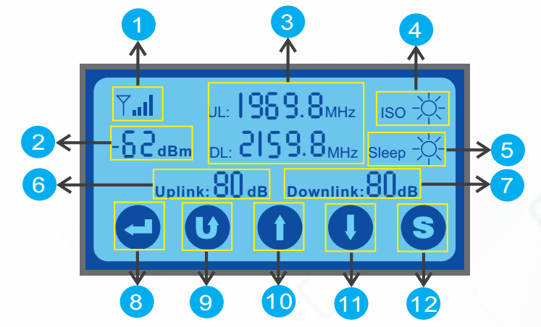
- 5 bars of the output signal strength indicator, which shows you the maximum output power of the repeater. Each signal bar represents 5dB.
- The specific value of the input signal strength measured in dBm, tell us the exact input signal level.
- Shows the UL&DL central frequency of the supporting system.
- Antenna Isolation Detection. When first power on the repeater, the repeater will detect the oscillation automatically between the outdoor antenna and indoor antenna.
- Uplink sleep Mode. The uplink of the repeater is in standby mode when there is no call or data transmission. It will activate immediately when a call a data session is initiated.
- Shows the UL maximum gain
- Shows the DL maximum gain.
- Enter for selection or confirm the settings.
- Back to the previous page or cancel the settings.
- Increase the gain or upward adjusting the central frequency
- Decrease the gain or downward adjusting the central frequency
- Smart function that repeater could set the gain automatically to prevent the Alarm. Press this icon to turn ON or turn OFF this function.

Electrical specification |  | Uplink | Downlink
Frequency Range | EGSM900Mhz | 880 ~ 915MHz | 925 ~ 960MHz
 | DCS1800MHz | 1710 ~ 1785 MHz | 1805 ~ 1880 MHz
 | WCDMA2100MHz | 1920 ~ 1980 MHz | 2110 ~ 2170 MHz
Max .Gain | SYN-13L-S | ≥ 65dB | ≥ 65dB
 | SYN-15L-S | ≥ 65dB | ≥ 70dB
 | SYN-20L-S | ≥ 70dB | ≥ 70dB
 | SYN-23L-S | ≥ 70dB | ≥ 75dB
 | SYN-27L-S | ≥ 75dB | ≥ 75dB
Max .Output Power | SYN-13L-S | ≥ 10dBm | ≥ 13dBm
 | SYN-15L-S | ≥ 12dBm | ≥ 15dBm
 | SYN-20L-S | ≥ 15dBm | ≥ 20dBm
 | SYN-23L-S | ≥ 15dBm | ≥ 23dBm
 | SYN-27L-S | ≥ 20dBm | ≥ 27dBm
Band width |  | Available upon request
MGC (Step Attenuation Via Touch Panel ) |  | ≥ 31dB / 1dB step
Automatic Level Control |  | ≥ 15dB, auto shut off after 15dB on Downlink
Gain Flatness |  | Tpy≤ 3dB (p-p)
Noise Figure |  | ≤ 6dB
VSWR |  | ≤ 2.0
Group Delay |  | ≤ 5.0μs
Frequency stability |  | ≤ 0.01ppm
LED Alarm |  | Standard
Power LED |  | Power Indicator
ALC LED |  | Orange @ ALC 1~5dB, Red @ ALC 15dB~20dB,
 |  | LED off after 5 seconds red
Mechanical Specifications |  | Standard
I /O Port |  | N-Female
Impedance |  | 50 ohm
Operating Temperature |  | -25ºC~+55ºC
Environment Conditions |  | IP40
Dimensions |  | 150*210*36mm
Weight |  | ≤ 2.5Kg
Power Supply |  | Input AC100~240V,output DC 12V / 3A
Intelligent Functions |  | Antenna Isolation Detection, Uplink Sleep, Smart Function, Input and Output Signal Strength Indication

