Press release

For immediate publication

5G NR EMF measurements – Narda STS is ready

Pfullingen, 27th October 2020 – Good news for all users of the Selective Radiation Meter SRM-3006 from Narda Safety Test Solutions. Looking at the new requirements for 5G NR, mobile network operators, organizations, private measurement service providers, and public authorities can also use their tried and tested 9 kHz to 6 GHz SRM-3006 for code-selective measurements of 5G signals. The EMF test and measurement specialist offers a software option for the SRM-3006 to enable code-selective measurement of 5G signals in frequency range 1 (FR1). This is similar to the well-known software options for UMTS and LTE. The hardware of the industry standard instrument for standard-compliant selective detection and evaluation of high frequency electromagnetic fields (EMF) remains unchanged.

There is a newly developed downconverter antenna for the upper frequency range FR2 (> 24 GHz). Work on this new antenna, which in the initial phase will be designed for up to 30 GHz (40 GHz in the second phase) will be completed shortly. The antenna will downconvert the upper 5G FR2 frequency band to enable the SRM to show the correct frequency easily. The SRM can already make frequency selective measurements on 5G signals perfectly. With code selective measurement and frequency extension to FR2, the SRM is the all-round carefree package for complete measurements concerning safety in electromagnetic fields.

Germany and many other countries require evaluation of the maximum possible exposure level when assessing immissions. Where this worst-case scenario cannot be realized in practice, regulations prescribe the use of suitable procedures to extrapolate the instantaneous immission to the required maximum value (the regulation known as 26. BImschV in Germany is an example of this). The SRM with code selective measurement already possesses precisely this internationally recognized technology that allows such extrapolation for UMTS and LTE. This means that the measurements are independent of the actual load on the system under test, and the results are unambiguous because they describe the highest possible exposure level. Also, these measurements can often be performed without information from the system operator, which further enhances the independence of the results.

The SRM handles both frequency selective and code selective measurement, and focuses exclusively on the areas that are needed for EMF measurements concerned with safety and personal protection. One of its unique qualities is that it provides the features that are needed in practice. Technicians can get started with measuring using the SRM without having to input much. The instrument automatically generates a clear and concise list with all the data that the test engineer needs for the evaluation. Not more, and certainly not less.

The other product lines offered by the Pfullingen-based RF test and measurement specialists are also future proof, ideally poised for 5G. As in the past, Narda is the company that still consistently covers the highest frequencies with its measurement solutions. Narda’s new RadMan 2 provides reliable personal protection right up to 60 GHz. The Nardalert Personal Radiation Monitor even goes up to 100 GHz. And the long-term monitors, too – both the broadband and the frequency selective Area Monitors – are ready for 5G in the long run. Talking of broadband measurements, the NBM-550 for example isotropically measures EMF from static fields right up to the microwave region (90 GHz). This means that even those frequencies that are still in the development phase of 5G are already covered.

[3572 characters incl. spaces]

This text along with the images is also available from
www.narda-sts.com/de under: Company > Press

[01 Narda 5G NR_200924.jpg]
Image 1: The application-oriented range of products from Narda Safety Test Solutions is ideally set for 5G NR in the long term. As the leader in the field of EMF Safety, RF test and measurement specialist Narda regularly discusses the state of the art with the key people in the industry, thus playing an active part in determining future technical regulations and standards.

[02 Narda 5G NR_200924.jpg]
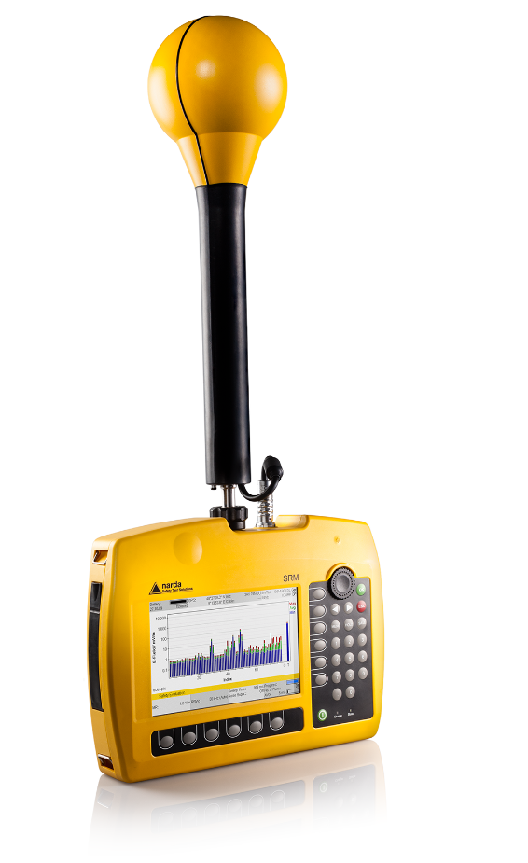
Image 2: Looking at the new requirements for 5G NR, mobile network operators, organizations, private measurement service providers, and public authorities can also use their tried and tested 9 kHz to 6 GHz SRM-3006 for code-selective measurements of 5G signals. The hardware of the industry standard instrument for standard-compliant selective detection and evaluation of high frequency electromagnetic fields (EMF) remains unchanged.

[ACHTUNG! Textlich modifizierter Abbinder - bitte bei Übersetzungen berücksichtigen]
Narda STS is a leading provider of measuring equipment in the fields of EMF Safety, RF Test & Measurement and EMC. The EMF Safety product spectrum ranges from broadband and frequency selective measuring devices, and EMF monitors for wide area coverage as well as personal safety monitors that can be worn on the body. The RF Test & Measurement range includes analyzers and devices for the measurement and identification of RF sources. The EMC sector offers instruments for determining the electromagnetic compatibility of devices under the PMM brand name. The range of services provided includes servicing, calibration (including accredited calibration) and ongoing training programs. The company operates its management system to comply with ISO 9001:2015 and maintains a calibration laboratory that is accredited to DIN EN ISO/IEC 17025:2005.

Narda STS has development and production facilities in Pfullingen / Germany and Cisano / Italy, and has its own representative in Beijing / China. A worldwide network of representatives guarantees closeness to customers.

Narda STS is part of L3Harris Technologies.

For further information, contact:  Texterei Jungmann  [Press contact]  Thomas Jungmann  Bahnhofstr. 42  D-88239 Wangen im Allgäu, Germany  Tel.: +49 7522 9899 850  Email: info@texterei-jungmann.de  http://texterei-jungmann.de | Narda Safety Test Solutions GmbH  Sandwiesenstr. 7  D-72793 Pfullingen, Germany  Tel.: +49 7121 9732 0  Fax: +49 7121 9732 790  Email: info.narda-de@L3Harris.com  www.narda-sts.com

® The name and logo are registered trademarks of Narda Safety Test Solutions GmbH and L-3 Communications Holding, Inc. – Trade names are the trademarks of their owners.

