Embargo: June 29th, 2021 at 3:00pm Taipei time (9:00am at Barcelona)

D-Link Enhances On-Premise Security and Network Management
with Nuclias Connect Hub Plus
Centralized network management solution Nuclias Connect is ideal for SMBs
that value robust security and scalability
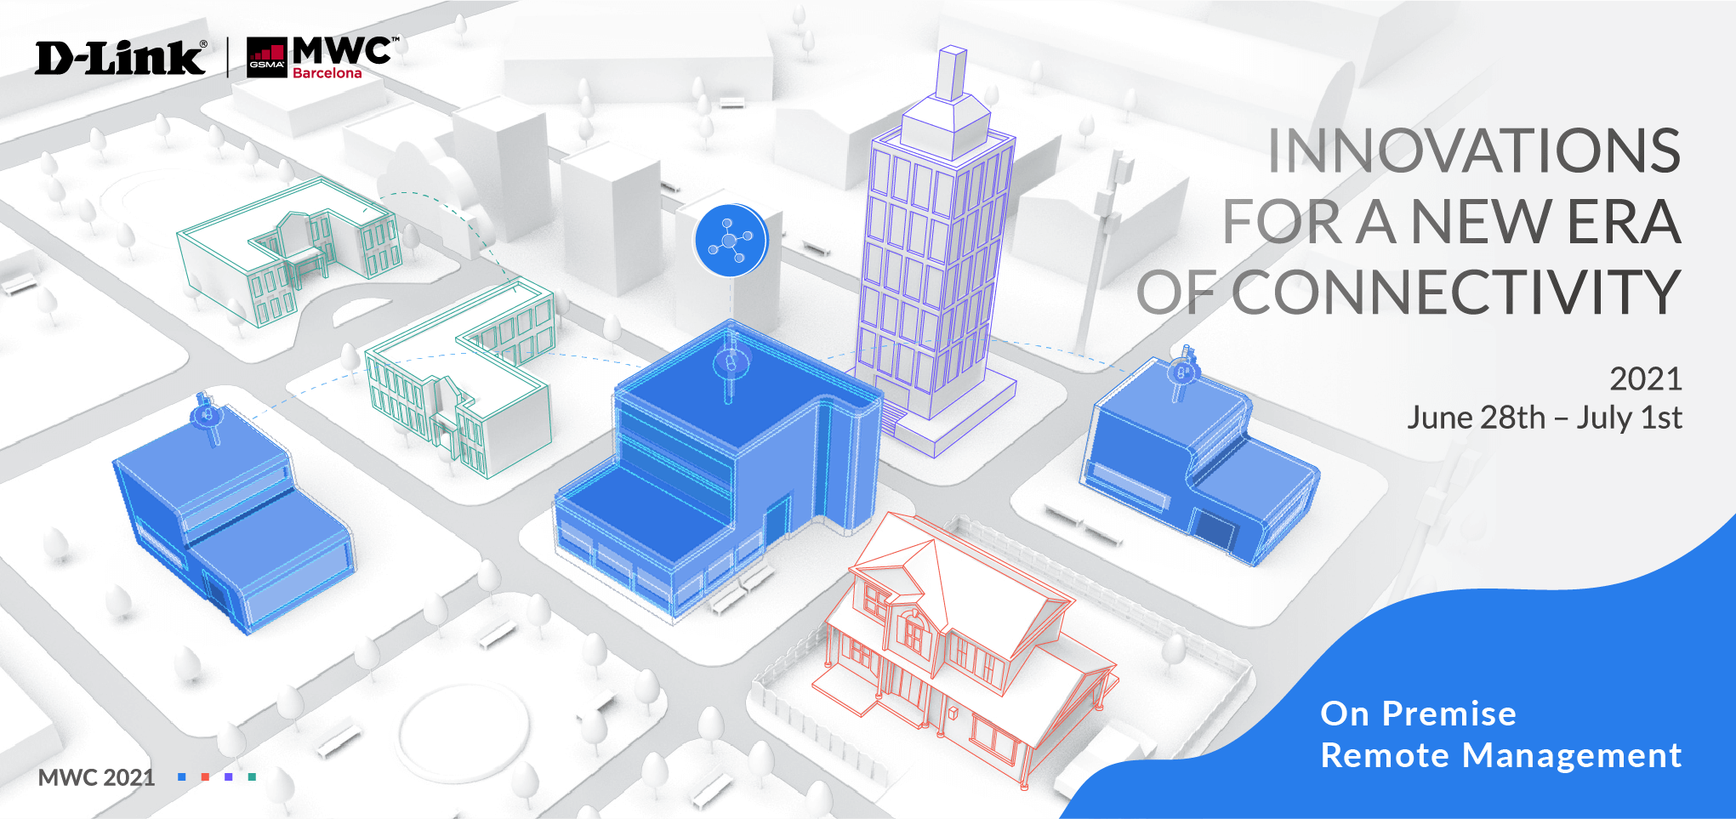

[MWC: June 2021] D-Link, a global leader in networking technologies, has unveiled the latest additions to its Nuclias Connect network management portfolio at Mobile World Congress, including the newest DNH-200 Nuclias Connect Hub Plus that is specifically engineered to improve business productivity and operations. Businesses increasingly demand on-premise networks that are customizable and enable easy, enhanced control. D-Link’s Nuclias Connect solutions are perfect for SMBs with in-house IT of medium skills and knowledge to leverage existing resources. Nuclias Connect is also available as a free-to-download software that offers license-free centralized management of up to 1,000 access points. Organizations with remote branch offices can centrally manage their surveillance network with the DNH-200 that works seamlessly with D-Link’s latest Nuclias Connect compatible Wi-Fi 6 Access Points and H.265 high resolution indoor and outdoor surveillance cameras.

The DNH-200 offers network management and video recording of up to 50 access points and 20 surveillance cameras. With a built-in controller software and network video recorder, the DNH-200 allows for real-time viewing and recording from up to 20 cameras simultaneously and playback of recorded videos in 1080p Full HD resolution. H.265 video compression improves coding efficiency and lowers storage and transmission costs. The DNH-200 also supports up to 5TB of camera footage storage, and network security is prioritized as sensitive data is kept on site. Additional features include multi-site management with device pre-configuration and advanced analytics for identifying problems and improving connections. Setup and management are quick and simple with the Nuclias Connect smart phone app and Nuclias Protect app.

For more information, please visit the D-Link MWC event website.

###

END OF ANNOUNCEMENT

About D-Link
D-Link is a global leader in connecting people, businesses, and cities with our computer networking solutions and technology. Our innovative products and services meet the needs of digital home consumers, small to medium sized businesses, enterprise environments, and service providers. D-Link implements and supports unified network solutions that integrate capabilities in switching, wireless, broadband, IP surveillance, and cloud-based network management. An award-winning designer, developer, and manufacturer for over 30 years, D-Link has grown from a group of friends in Taiwan into a global brand with over 2,000 employees in 60 countries.

D-Link Corporation PR Contact:
Angela Lo
Angela.Lo@dlinkcorp.com +886-2-6600-0123 #6652

