Embargo: June 28th, 2021 at 3:00pm Taipei time (9:00am at Barcelona)

D-Link Unveils 5G Private Networks Designed to
Transform Enterprises at MWC

Global leader presents its latest 5G private network technologies, designed for
boosting enterprise productivity
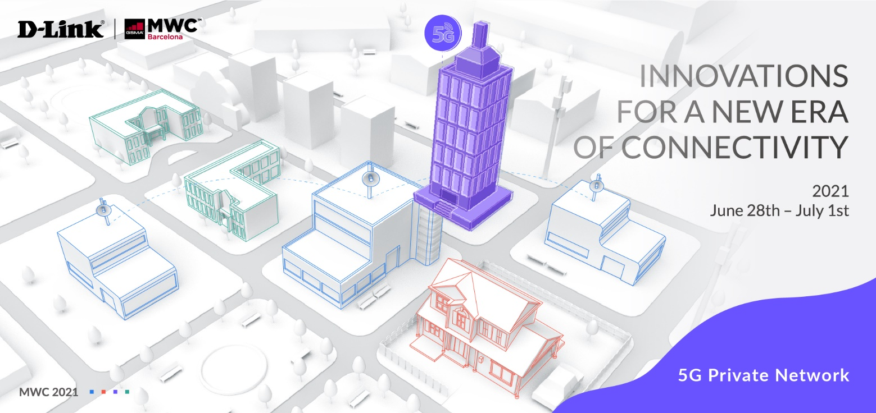

[MWC: June 2021] D-Link, a global leader in networking technologies, today announces its latest private 5G network innovations, specifically designed for enterprises and SMBs, to address mounting critical IoT connectivity demands and drive new efficiencies in the current digital revolution known as Industry X.0.

Industry digitalization is advancing, and businesses need to have the infrastructure in place to deliver local, customized services with reliable wireless connectivity.

D-Link expands 5G to industrial IoT by offering 5G private networks to support massive IoT deployments and provide multi-gigabit speeds with virtually unlimited capacity for high bandwidth and low-latency services.

With dedicated resources for local networks that are independently managed and easy to deploy, D-Link’s 5G private network technologies provide enterprises and SMBs with optimized, tailored performance that targets their specific business needs.

D-Link’s reliable and secure 5G fixed wireless access is a competitive option against traditional fixed-line broadband services, which are often challenging to manage and expensive to deploy in many environments. 5G FWA also opens up new opportunities for mobile operators worldwide to deliver managed voice, video, data, and IoT services.

D-Link offers a range of enterprise products for constructing robust 5G private networks, including data center switches, surveillance cameras, access point, and the new 5G NR M2M Gateway. D-Link’s DWM-3010 5G NR M2M Gateway facilitates 5G broadband connectivity with speeds of up to 1 Gbps for blazing-fast downloads, ultra-low latency, and reduced congestion.

With the DWM-3010 5G NR M2M Gateway, users can connect up to 50 devices in heavy-use working environments, and the system features multiple industrial features for efficient communication between devices. What’s more, it comes with a rugged design that allows it to withstand a wide temperature range in any setting – meaning remote, centralized management is easy with D-Link Edge Cloud Solution.

For more information, please visit the D-Link MWC event website.

###

END OF ANNOUNCEMENT

About D-Link
D-Link is a global leader in connecting people, businesses, and cities with our computer networking solutions and technology. Our innovative products and services meet the needs of digital home consumers, small to medium sized businesses, enterprise environments, and service providers. D-Link implements and supports unified network solutions that integrate capabilities in switching, wireless, broadband, IP surveillance, and cloud-based network management. An award-winning designer, developer, and manufacturer for over 30 years, D-Link has grown from a group of friends in Taiwan into a global brand with over 2,000 employees in 60 countries.

D-Link Corporation PR Contact:
Angela Lo
Angela.Lo@dlinkcorp.com +886-2-6600-0123 #6652

