Application Form for K-Startup Fundraising Program

󰊱 Overview
Company name | Waynehills Ventures. co., ltd. | Registration date | 23/05/2019
Industry Sector | Application Software Publishing | Number of Employees | 15
English Website | https://www.waynehills.co/
LinkedIn URL | -
Product·Service  Summary | We provide text as digital content through automatic video production software using artificial intelligence.

󰊲 Financial Statement
Last  year  (2020) | revenues | 868,854,546 KRW
 | expenses | 525,191,103 KRW
 | profit/loss | 1,315,927,826 KRW
Previous funding  (capital raised, stage) |  | 1,641,471,863 KRW / BNK Venture Investment, Postech etc.
Amount to be raised/current round |  | 1,000,000,000 KRW / Series A
Pre / Post-money valuation |  | 15,000,000,000 KRW / 80,000,000,000 KRW
Exit strategy |  | M&A with Conglomerate
Please provide estimates for the coming years
ITEMS |  |  | Year 1(2021) | Year 2(2022) | Year 3(2023)
Revenues |  |  | 8,500,000,000KRW | 15,000,000,000KRW | 30,000,000,000KRW
Funding needed |  |  | 1,000,000,000KRW | 3,000,000,000KRW | 10,000,000,000KRW

󰊳 Contact information
Founder
Last name | Yi | First Name | Su min
Email | ceo@waynehills.co | Phone number | +82-10-4111-9003
Job experience, educational background, etc. | Bachelor’s degree in Electronic Engineering from Hong-Ik University  10 years of experience in Content production planning  Patent registrations(10case) and application(11case) related TTV, STV r
LinkedIn URL | -
Participants other than Founder
Last name | Lee | First Name | Sun ju
Email | Hakgok97@waynehills.co | Phone number | +82-10-6656-0144
Job experience, educational background, etc. | Doctor’s degree in Finance from Chung-Ang University  H& Consulting Business Department Manager (2018.06-2020.04)  Sejong Counsel Co., Ltd. Senior Researcher (2017.07-2018.06)
LinkedIn URL | -

󰊴 Product·Service
1. Wayne Hills Inc. Technologies
1) Background of the business item
- To address the pain-point which is the fatigue of consumers that comes from reading text information.
- Wayne Hills Inc. sees it as pain-point that companies are spending hundreds of billions of dollars a year for printing unread printouts. Thus, we provide a cost-reduction solution for companies.
- Our technology, which can reduce wasted printouts; create and provide intuitive and easily accessible content, will be a solution that can reduce costs for many companies and effectively provide corporate information to consumers

2) Key function
- TTV(Text to Video). Development of AI (Artificial Intelligence) software that automatically converts/produces text data into digital video content.
- Automatically summarizes text data through AI machine learning and natural language processing. It is and AI software that finds the analyzed image, video, sound source etc. by analyzing the keywords of the summarized text and automatically converts it into digital video content corresponding to the story.
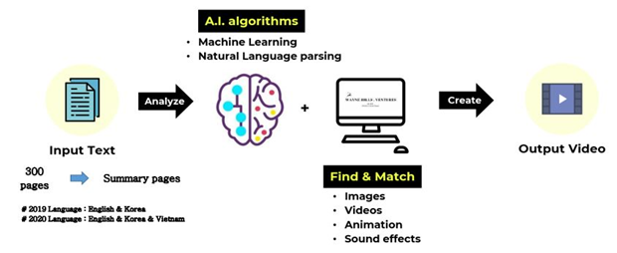
- Summarization: Summarize text data of 300 pages or more into 300 worlds or more in key sentences and keywords through natural language processing (NLP) and machine learning (ML) technology.
- Matching: Search keywords derived through machine learning and match labeled images, videos and sound sources.
- Merge: Generate by merging the matched images, videos, sound sources and main keywords into one video content.
- Editing: Customized editing is available for images of additional texts of the customers (Video producers)
- Distribution: Automatic distribution to social media such as Youtube, Facebook and Instagram is available for promotion and customer attraction.
2. Technology competitiveness
1) Comparative Analysis with competitor
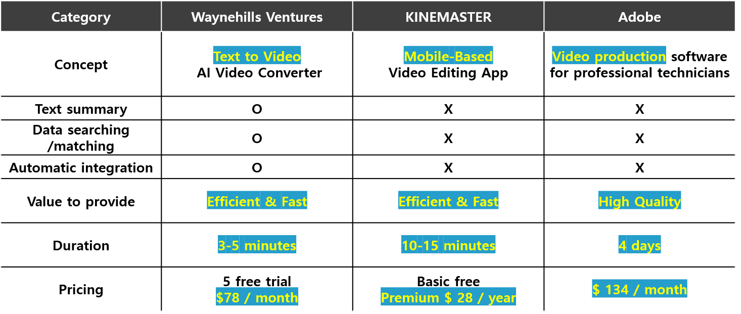

- The software provided by existing competitors (KINEMASTER, Adobe) convert video content based on image and are similar to Wayne Hills Inc.’s commercialized service, Wayne Hills A.I.

- KINEMASTER
- Current status in the Korean market: Over 120 million global downloads.
- Kinemaster, a leading Korean video editing tool company, has launched a new video editing app “BEATSYNC” that allows users to create videos with photos to match the music beat, like TikTok, which has emerged as a global trend. It is a user-friendly tool that allows users to create trendy videos easily even for the beginners.
- It’s a small organization where last year’s sales amounted to more than KRW 19.2 billion, and the numbers of global downloads was more than 120 million.

- ADOBE
- Overseas market trend and status: Most used video production tool.
- Adobe, which is used by over 90% of designers and art directors developing video content, is currently developing various technologies using artificial intelligence.
- It is the content production company with the highest-end AI and video editing technology such as GoFigureSneak feature that creates digital content through AI which automatically tracks the human body and captures motions; and ProjectSoundSeek, which eliminates unnecessary sounds in the image, etc.
- Video editing tools are emerging competitively at home and abroad, and ADOBE is showing an outstanding number of downloads from the customers.

▶ It is difficult to say that the above-mentioned companies are direct competitors of Wayne Hills Ventures. Wayne Hills Ventures holds a unique technology that automatically summarizes texts based on artificial intelligence and automatically produces images using the algorithm of the summary.

2) Experts in all fields
- TTV is the service that automates several steps of summary, video clip matching and video merging, editing for easy use to end users.
- It is a service that requires experts in the Media, AI, General development and service fields.
- Wayne Hills Inc. has a manpower structure to support all fields, so it is possible to support the service without difficulty.
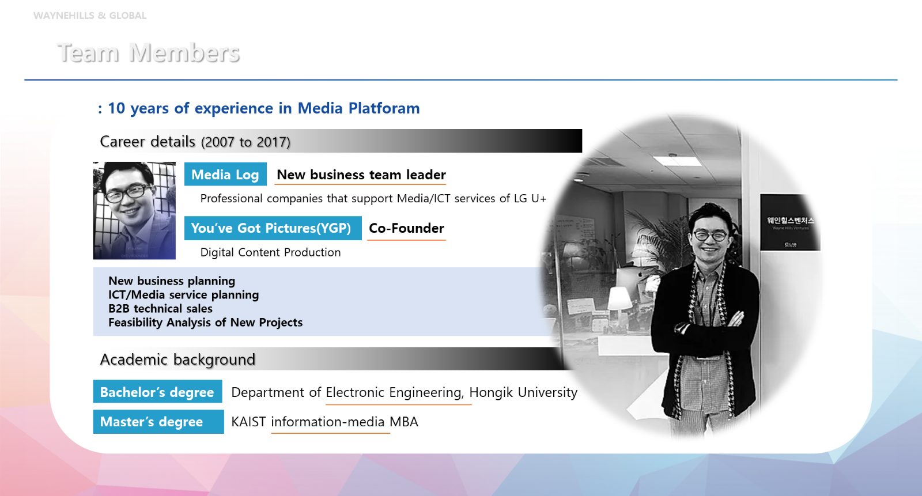

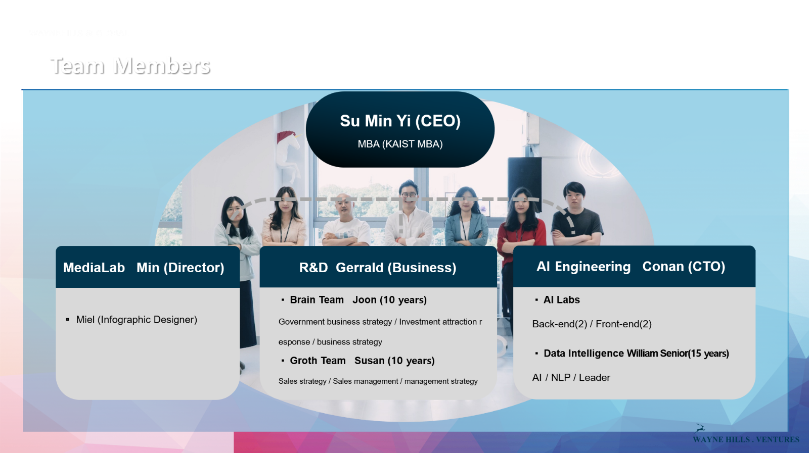

3) Wide range of industrial clients
- Publisher
- Signed a SW Use Agreement with Online Publisher “Yes24” (2019)
- Share revenue from promoting video content as well as using SW (2020)

- Financial / Insurer
- Converting the terms and conditions of financial and insurance companies into video content to provide HR education, internal reports and contents for customer distribution (agree to the terms and conditions).
- Signed a contract with Shinhan Financial Investment, Samsung Securities, Hanwha Life Insurance, Orange Life (2020)

- Platform / Media company
- Contracts are under discussion with additional services from platform and media companies (B2B2C business)

- Electronics company
- Signed a contract with Samsung Electronics and LG Electronics
- Collaborate on contents with various affiliates such as Samsung Electronics, Samsung Economic Research Institute, Samsung Life Insurance etc.
- Samsung Electronics Mobile Business Department S20 User’s manual content production
- LG Electronics promotional video production and Collaboration will be conducted to produce R&D tasks and reports as video contents in the future.

- Culture Industry enterprise
- Collaborate with CJ ENM, Lotte Culture Works
- Create video content for the scenario atmosphere of CJ ENM’s dramas, movies etc. and share it in pre-rehearsal
- Production of video contents related to the operation of Lotte Culture Works movie theater

- Start-up, Small and Medium-sized business
- Providing video content such as introduction of company/team members at a one-tenth lower price than before
- Operation of ‘Startup support programs’ with government agencies

4) Partnerships and International connections
No | Company | Cooperation | Nation | Date
1 | Korea University | Cooperation in the development of Intelligent application services technology | Korea | 05/20
2 | Postech Holdings | Cooperation in the development of natural language processing technology | Korea | 06/20
3 | SELECTSTAR | AI Data voucher support project | Korea | 07/20
4 | Saltlux | Data voucher support project | Korea | 07/20
5 | Hana Bank Agile Lab | R&D Convention | Korea | 08/20
6 | Alryejoom | Media Joint Business Agreement | Korea | 08/20
7 | Little song music | Licensing Agreement | Korea | 09/20
8 | KMAC | A business agreement for mutual development of micro enterprise-related projects and the New Deal industry | Korea | 10/20
9 | Ministry of Gender Equality and Family | Gender-Balanced Inclusive growth partnership business agreement | Korea | 10/20
10 | Korea International Trade Association | A business agreement for discovering and fostering promising startups | Korea | 11/20
11 | Samsung Electronics | Patent transfer (5 patents are signed) | Korea | 12/20
12 | HI PARTNERS | Business Agreement | Russia | 07/20
13 | Tatra | Business Agreement | Russia | 07/20
14 | AI and Application Research Group at the University of Wisconsin-Milwaukee | Mutual cooperation for artificial intelligence research | USA | 09/20
15 | Beijing Jinliyang Investment | Sign a letter of intent to invest | China | 11/20
16 | Beijing Yingruochangsheng Investment | Sign a letter of intent to invest | China | 11/20

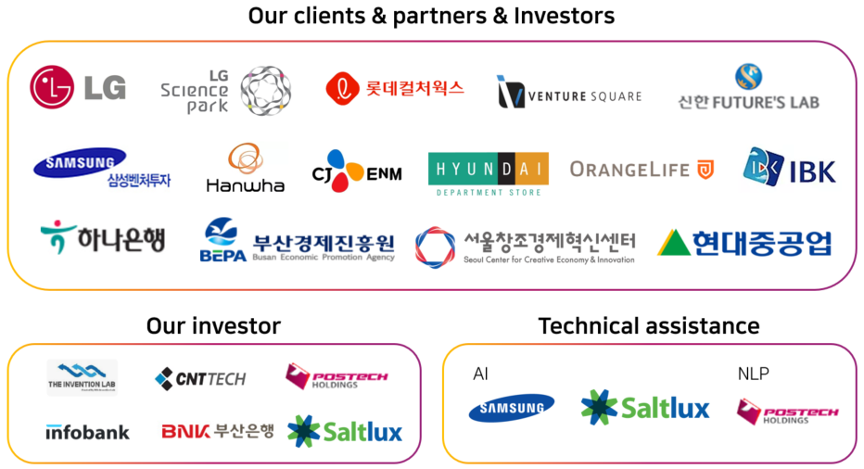

3. Growth Potential
1) Revenue model
- Domestic video content production services are generally requested to freelancers and video production companies on offline
- As a result, SW, which supports video content production, is characterized by a tool that can be used by freelancers, industry experts and technicians, and has low utilization of AI technology
- As a B2C business, the service that can produce video content is mainly provided on a mobile basis and supports the production of video with user’s photo data
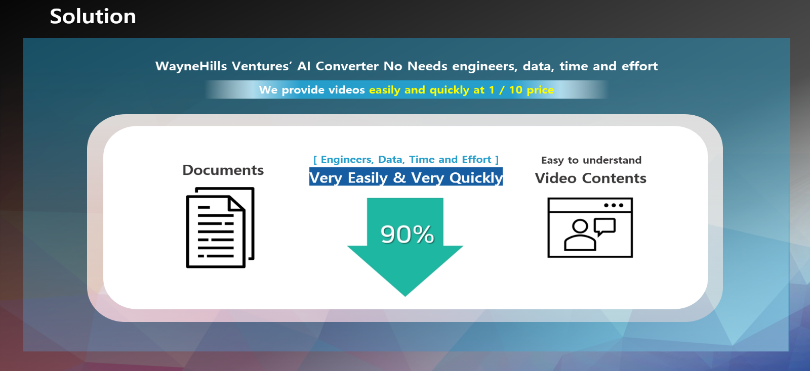

- B2B & B2C Market
- Expanding references in various fields for validation of appropriate categories of video content
- Settle in the market through expansion of attracting new customers in areas that have been proven appropriate.
- Expanding from B2B Enterprises to B2B and B2C
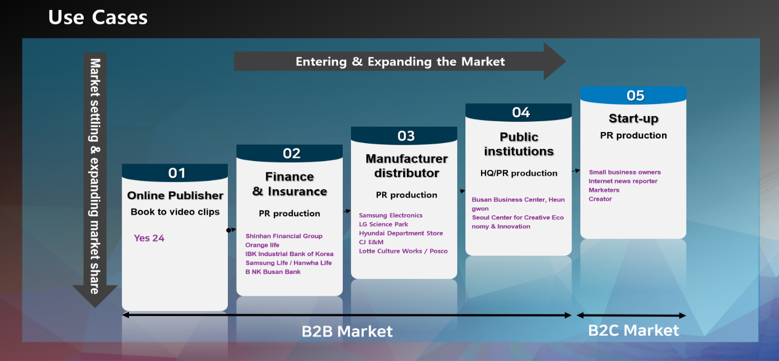
- We create and deliver content internally to large and medium enterprises by signing annual supply contracts, dramatically lowering production cost per case through AI technology to gain price competitiveness.
- Expanding business models based on SaaS. In the future, users can directly create video contents with their own services in the internet environment, and monthly subscription models (79,900 won per month, free of charge until 5 production)

[Planning business model Expansion on SaaS]
Step | Content | Details
Development Complete | Commercializing Alpha Version | -Commercializing Alpha version as a business model for B2B Enterprises  - 200 million won in sales in 2019  - Attract customers and partners from large and medium enterprises by signing annual supply contracts
Development Progress  (~2021) | Beta version to be released | -SaaS will be released in December 2021  - Enterprise membership is introduced to allow annual and monthly subscriptions, not annual supply contracts.  - Improve user accessibility by allowing members to use directly in the internet environment.
Development Plan  (First half of 2022) | Full service open | -Official service operation in the first half of 2022  - Attract customers through B2B SaaS service operations validation and accumulated data  - (B2C) Improve CS to attract individual members  - (B2B&B2C) Provided as an additional service on the platform, which can be provided free of charge to platform users

- Marketing Strategy
Target | Classification | Details
X | GOD | Enterprises classes requesting content production with huge financial power.
X | TOP Player | Professional content production classes (Broadcasters, Professional Youtubers)
1st Target | Semi Creators | The classes that have content creation needs but lack skills. (General youtubers, Professional sales representative - Car, Financial, Insurance, seller)
2nd Target | Anonymous | Content consumers who are not interested in video production. But the classes interested in self-expression (TikTok, Snow, Facebook etc.)
X | Ghost | Consumers who never want to show up online and who don’t even have personal social media. The Inaccessible classes

3) IP Protection
- Preparing to apply for IP protection

4) Biggest Challenge: Advanced Technology
- Technology development status
- When the user enters text, artificial intelligence identifies and classifies the text type, adopts a suitable summary method (extraction or synthesis), and enhances the function to derive an accurate summary.
No | Service name | Details | Development stage
1 | VSW | Automatic conversion and  editing of image data into video | Commercialization  Completed
2 | Wayne Hills A.I | Automatic conversion and  Editing of text data into video (AI) | TRL 7 Steps

- End Product
- Extract natural summaries through artificial intelligence-based algorithms.
- Recommend video, image and sound source using machine learning and natural language processing based on the summary.
- Create video content corresponding to the context of the story.
- Edit image and present alternative image search functions for some images
- Build a platform to share videos created and information.
Text  Summarization | ◦ Development Goal  - Above ROUGE-1 43
◦ Technology development content and scope
- ROUGE: Recall-Oriented Understudy for Gisting Evaluation. A scale to measure the performance of text summaries. It is calculated from 0 to 100, and the higher it is, the better the summary is. Baseline is 25.
- Review text summarization methodology (Machine Learning & Deep Learning)
- Unsupervised Methods: TextRank, WordRank
- Supervised Methods (Extractive)
- Conditional Random Field (CRF)
- Convolutional Neural Network (CNN)
- Supervised Methods (Abstractive)
- Recursive Neural Network (RNN)
- Long Short-Term Modeling (LSTM)
- Sequence to sequence modeling (seq2seq)
- AutoEncoder
- Generative Adversarial Network (GAN)
- Transfer Learning (Extractive & Abstractive)
- Bidirectional Encoder Representations from Transformers (BERT)
- Bidirectional Autoencoder Representations from Transformers (BART)
- Text-To-Text Transfer Transformer (T5)
- Deep Learning Frameworks
- Tensorflow
- Pytorch
- Keras
- Caffe 2
- AWS Sagemaker
- Google Colab
Media  Search | ◦ Development Goal  - Extract main keywords from text  - Search for media matching the keywords  - Integrate the searched media file into one video
◦ Technology development content and scope
-Develop technology to extract main keywords for media search using natural language processing (morpheme analysis) technology from a massive amount of text of about 300 pages
- Tag part of speech / process morpheme analysis with Konlpy morpheme analyzer
- Search for sound sources, images, and videos stored in Elastic Search Engine by keyword (Wayne Hills Venture holds 5 million cases)
- Create a single video by integrating various types of media searched by each frame based on a summary text sentence.
- AWS Media Converter is to be introduced
Media  Platform | ◦ Development Goal  -Automatically distribute auto-created videos to various media platforms and influencer channels owned by Wayne Hills Ventures
◦ Technology development content and scope
-Develop technology that automatically distributes to the media platform preferred by the user and the influencer channel owned by Wayne Hills Ventures
Building a  Cloud server | ◦ Development Goal  - Build all systems in a cloud server environment
◦ Technology development content and scope
- Select cloud service selection
- Develop integration technology between services
- Build an endpoint
- Develop Service API

4. Additional Information
1) Demo Video
- https://www.youtube.com/watch?v=sAcRhgaYNrA

2) Wayne Hills Youtube
- https://www.youtube.com/channel/UCUZ0zW9cPLMd9DCDAxV813Q/videos

