Embargo: June 28th, 2021 at 3:00pm Taipei time (9:00am at Barcelona)

D-Link Futureproofs the Modern Smart Home with
5G, AI, and Wi-Fi 6 Launches

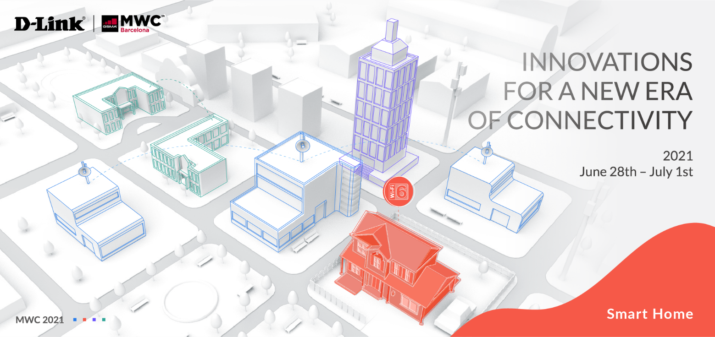
The company’s latest smart home launches combine cutting-edge technologies to deliver seamless connectivity to post-pandemic home networks

[MWC: June 2021] D-Link, a global leader in smart home technologies, has unveiled its latest range of smart home devices specifically designed to support remote post-pandemic workforces at this year’s Mobile World Congress (MWC) in Barcelona, Spain.

The impact of the global pandemic on workforces, and the overwhelming rise in remote working, means businesses have had to adopt new ways of working to keep teams connected. As a result, heavy bandwidth applications at home have significantly increased, along with the use of technologies such as 8K video streaming and virtual and augmented reality. Today’s broadband users demand low-cost networks with accelerated connectivity speeds, reliable access, and efficient deployment. Yet, many people around the world still suffer from slow, unreliable Internet.

D-Link’s smart home ecosystem combines 5G, AI, and Wi-Fi 6 technologies to transform homes into an intelligent, automated, extension of the office – providing the ecosystem required to sustain a seamless connection for work and leisure.

The company’s all-new 5G/LTE Outdoor CPE, DWP-1010, delivers lightning-fast Gigabit speeds with maximum redundancy, providing easy access for multiple users and a large number of connected devices. Fully equipped with a rugged design and flexible deployment options, making it easy to install anywhere for optimum connectivity. The DWP-1010 is specifically engineered to bring advanced 5G connectivity into the home or the workplace.

What’s more, D-Link’s upcoming AI Series allows people to enjoy a high-speed connection across all devices within the home. The all-new series includes a router, mesh router, and extender that features sophisticated AI technology to recognize and combat connection problems and optimize performance.

D-Link’s latest mydlink smart home cameras also leverage AI technology to provide high-accuracy surveillance and protection for the home.

Lastly, with D-Link’s Wi-Fi 6 USB Adapter, users can quickly and easily upgrade their desktop and notebook computers to the latest Wi-Fi 6 technology for greater network data rates, capacity, and performance even in dense, congested environments.

For more information, please visit the D-Link MWC event website.

###

END OF ANNOUNCEMENT

About D-Link
D-Link is a global leader in connecting people, businesses, and cities with our computer networking solutions and technology. Our innovative products and services meet the needs of digital home consumers, small to medium sized businesses, enterprise environments, and service providers. D-Link implements and supports unified network solutions that integrate capabilities in switching, wireless, broadband, IP surveillance, and cloud-based network management. An award-winning designer, developer, and manufacturer for over 30 years, D-Link has grown from a group of friends in Taiwan into a global brand with over 2,000 employees in 60 countries.

D-Link Corporation PR Contact:
Angela Lo
Angela.Lo@dlinkcorp.com +886-2-6600-0123 #6652

