Press release

For immediate publication

Narda RadMan 2 – Premium safety 2.0
in electromagnetic fields

Pfullingen, Germany, 17th June 2020 – One year ago, the EMF safety experts at Narda STS presented the new RadMan 2, the successor to their two decades old all-time best selling Personal Monitor. This device was, is, and will continue to be an essential part of the personal safety equipment (PSE) of everyone who needs to work in or around electromagnetic fields (EMF). Developed and manufactured in Germany just like the original RadMan, this new device is ready to continue with the long term success of the original. The RF measuring device specialists have equipped it with new, intelligent features while retaining the old qualities, future proofed it by extending the frequency range up to 60 GHz, and made it considerably less expensive to buy. As a result, some well-known cellphone network providers have equipped large numbers of their workforce with the RadMan 2.

As far as the safety of their employees is concerned, those in positions of responsibility in telecommunications and broadcasting, industry, air traffic control, the military, and the relevant government authorities take no chances. Health and safety at work also always involves a sense of personal responsibility and an appreciation of the need to exclude anything that might be a health risk. The workforce is exposed to high intensity electromagnetic fields on a daily basis as the 5G rollout proceeds apace. Right around the world, stakeholders are therefore relying on the decades-long experience of the market leader in EMF safety. Regardless of whether in the near field of radar antennas, broadcasting stations or cellphone base stations, or close to industrial high frequency smelting and welding equipment, they can rely on this icon of EMF safety. With the new RadMan 2 (figure 1) they have “Premium Safety 2.0” on their belt.

Particularly in unknown electromagnetic field situations where there is no certain knowledge of the actual EMF conditions, RadMan 2 takes the initiative in such complex monitoring tasks. Immediately after it is switched on, it performs an automatic sensor test to ensure that it is working correctly, and at all times gives you reliable warning whenever the limit values are exceeded. The new test and warning device alarm signals are louder and brighter than before, and there is now even a vibrating alarm to ensure that users never miss any warning of a dangerous situation.

The XT version of the RadMan 2 for up to 60 GHz currently covers the widest frequency range on the market and thus gives the wearer reliable and sure warning even at radio and radar frequencies and also of 5G millimeter waves. Narda also produces a second version, the LT, which covers frequencies up to 8 GHz and has a leaner set of features. This device makes premium safety attractive for people who only occasionally work in EMF, such as tradespeople.

The list of RadMan 2 features is long, and all of them contribute to maximum safety in electromagnetic fields. It therefore comes as no surprise to learn that the RadMan 2 was recently nominated in Category B (Fire and explosion protection, industrial security) for the prestigious GIT Security Award 2021 (figure 2). Of particular interest here is the automatic sensor test. Realized for the first time in a Personal Monitor, this makes it unnecessary to use an external test transmitter because it checks the correct function of its own sensors immediately after it is switched on. Without any further action, the user can concentrate on their job, knowing that they are protected. Even the battery charge status is monitored automatically, and a full charge will give an almost unbelievable operating time of 800 hours.

The RadMan 2 is equipped with E field (electric) as well as H field (magnetic) sensors for use in the near and far field of TV and radio antennas. The device will therefore automatically give the correct warning, regardless of the type of field or the distance from the source. This means that the technician does not need to know anything about the field or have to make any settings on the device. Also, whenever the warning device sounds the alarm, it is always based on the correct standardized values, i.e. the actual exposure level as a percentage of the upper limit value of the applicable standard: ICNIRP, Directive 2013/35/EU, FCC, or Safety Code 6. The patented “shaping with frequency response evaluation” feature automatically takes account of the fact that the permitted limit values specified in the standards are frequency dependent, so the alarm thresholds vary as a result. The enormous advantage to the user is that there is no need to set the active limit value on the device or to make tedious conversions of the displayed values.

The new Personal Monitor guarantees maximum safety when working in critical electromagnetic fields by systematically excluding sources of error, such as damage to the device or incorrect operation. For example, there is a special RF absorber between the body and the sensor to ensure that the actual field strength is registered precisely and correctly. This is the only device of its type to in this way prevent the corruption of results caused by the effects of reflections from the wearer’s body. The RadMan 2 is always ready to give audible, visible, and feelable warning when the invisible electromagnetic fields in the frequency ranges even of future applications approach the internationally standardized limit values.

[5.506 characters]

You can also find this text and the press photos at:
https://www.narda-sts.com/en under the subject: Company > Press

[01 Narda RadMan 2 P2_200617.jpg]
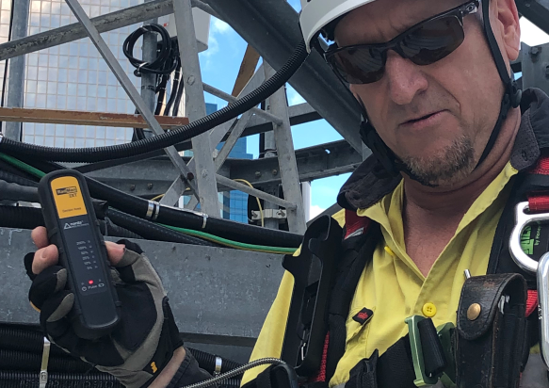
Figure 1: Particularly in unknown electromagnetic field situations where there is no certain knowledge of the actual EMF conditions, RadMan 2 does all the thinking for you in such complex monitoring tasks.

[02 Narda RadMan 2 P2_200617.jpg]
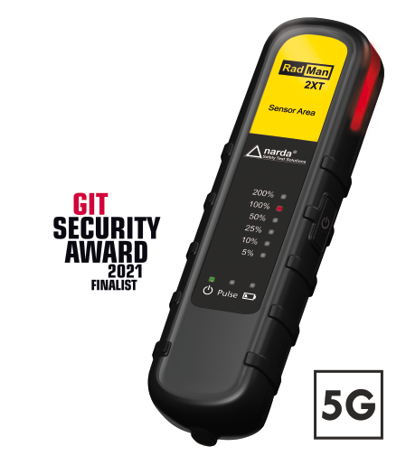
Figure 2: Narda’s RadMan 2 excels with numerous intelligent details such as the first ever automatic sensor test and its patented “shaping with frequency response evaluation”. No wonder that this device has been nominated as a finalist for the prestigious GIT Security Award 2021.

Narda is a leading supplier of measuring equipment for EMF Safety, RF Test & Measurement, and EMC. The EMF Safety product spectrum covers broadband and frequency-selective measuring devices, and EMF monitors for wide area coverage as well as personal safety monitors that can be worn on the body. The RF Test & Measurement range includes analyzers and devices for the measurement and identification of RF sources. The EMC sector offers instruments for determining the electromagnetic compatibility of devices under the PMM brand name. The range of services provided includes servicing, calibration, and training programs. The company operates a management system that complies with ISO 9001:2015 and operates a calibration laboratory that is accredited to DIN EN ISO/IEC 17025:2005.

Narda has development and production facilities in Pfullingen / Germany and Cisano / Italy, and has its own representative in Beijing / China. A worldwide network of representatives guarantees closeness to customers.

Narda is part of L3Harris Technologies.

For more information, contact:  Texterei Jungmann  [Press contact]  Thomas Jungmann  Bahnhofstr. 42  D-88239 Wangen im Allgäu  Tel.: +49 - 7522 / 9899-850  E-Mail: info@texterei-jungmann.de  http://texterei-jungmann.de | Narda Safety Test Solutions GmbH  Sandwiesenstr. 7  D-72793 Pfullingen  Tel.: +49 - 7121 / 97 32 - 0  Fax: +49 - 7121 / 97 32 - 790  E-Mail: info.narda-de@L3Harris.com  www.narda-sts.com

® The name and logo are registered trademarks of Narda Safety Test Solutions GmbH and L-3 Communications Holding, Inc. – Trade names are the trademarks of their owners.

