ADINNO 4K OBVAN & 4K OTT Won Both China National Media Award and "2017BIRTV" Award

PR Newswire:
BIRTV 2017 Beijing, dated 23rd Aug., ADINNO INC. will be presented in BIRTV Hall 8 International Museum 8A34 booth, grand display this year two awards products - National Media award "4k OBVAN", BIRTV Award "SEEi-I media mobile broadcast platform (4k OTT) ", and will showcase new products, including" SEEi-8 / SEEi-10 Internet All-In-One production"," District of county community service media solutions "," Merged solution on Radio and Mobile Live Stream "," HEVC H.265 4k / VR Media Player "and so on.

ADINNO focus on the 4k industrial chain, put effort and investments on the 4k source content, 4k OBVAN and 4k OTT cloud , 4k HEVC player / APP, 4K router /set box etc. Thus to match with all application scenes,TV/radio/cable/internet/mobile and social screens.

Regarding 4K contents ,invested and partnership with 4KUniverse which is online already with SES 4K /Amazon Fire TV / ROKU TV/Sony bravia 4K,etc. The first one in the world for original 4K content to the market.

The national media award by ADINNO 4K OBVAN, including innovative All-In-One production device called SEEi-8 or SEEI-10, which can support one-stop shop on video production and streaming, for 4K through mixed cellular wireless/ fixed / satellite communication technology. Plus ADINNO 4K OTT(SEEi.TV) - another 2017 BIRTV award, Thus can make the 4K live stream directly into IPTV/ TV/ cable/ satellite and of course smart mobile phone, through ADINNO 4K OTT solution--SEEi.TV. This is the first one end to end live 4K streaming from the field events such as music, sports...directly to the screen of end users by seconds only.

In additionally ADINNO developed 4K HEVC player and mobile APP as well as H5 web and social networking Wechat applet, as well as 4K router /set box etc. So ADINNO can offer the best economic 4K OTT solution to the international fixed/mobile service operators/carriers, to help the operator/carriers to offer value-added content service, thanks to the 4K HDR special feature which ADINNO trust this HDR can make interesting attractive sense by the end users, through ADINNO 4K OTT and its cloud auto- Transcoding for mobile screen .

4K industry blooming up quickly, the province governor from south China, plan to invest USD 150 millions to 4K industry, and expected to get GDP value as USD 100 Billions .

Overall, with years effort, ADINNO is the top and leading 4K end to end live streaming provider, offering affordable 4K OBVAN,SEEi-8 or SEEI-10 internet All-In-One production,4K SEEi.TV OTT and the end user’s 4K Router / set box , HEVC player, mobile APP, etc. ADINNO advanced 4K solution can match with the full scale application, media, telecom/mobile,internet market.

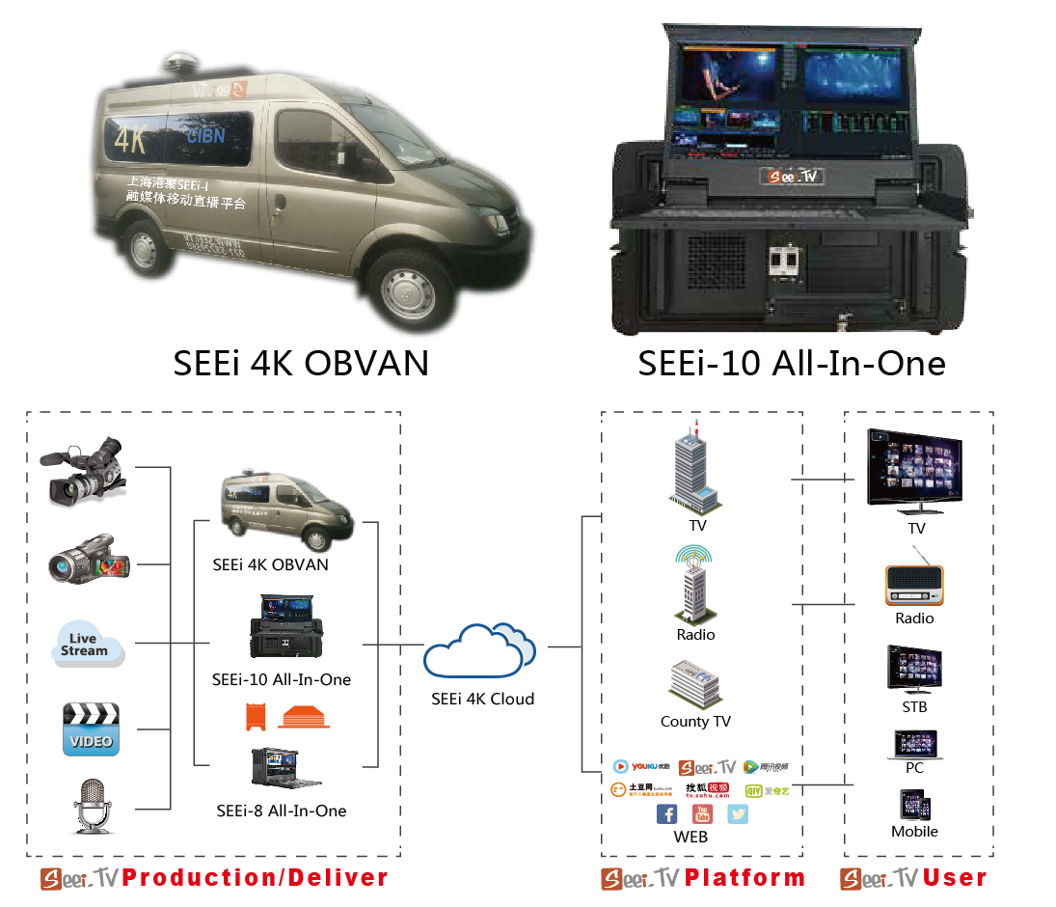

About ADINNO:
ADINNO Inc. located in Beijing, Shanghai,Bay area USA.
ADINNO Inc. does have unique experience in core technology, such as baseband, RF chip design, wireless communications, satellite communications, video processing and cloud computing. The product line includes intelligent mobile terminals, intelligent systems and cloud services (cloud UHD Live Cloud SEEi.TV-www.seei.tv).
ADINNO is the top and leading 4K end to end live streaming provider, offering affordable and economic total solution.

For more information, please visit the ADINNO website at www.adinno.org.

Please follow us on:
Facebook : https://www.facebook.com/adinno.seeitv/friends
Twitter: https://twitter.com/adinno_inc
Linkedin: https://www.linkedin.com/in/inc-adinno-ba331b145/
Instagram: https://www.instagram.com/seei.tv/

News / Sales Contact:
Wang Yunqing + 86-21-5522-9560
Grace Liang +86-13120974523
USA Bing zhang :+1(408)524-1600
Email: adinno@adinno.org
4k live technology platform: www.seei.tv

