Press release

For immediate publication

SignalShark Open Platform – High Performance Analyzer Without Limits

Pfullingen, Germany, 16th April 2020 – The SignalShark Real Time Spectrum Analyzer from Narda Safety Test Solutions is designed to be an open platform. By integrating a powerful computer with the Windows 10 operating system, the RF testing specialists have decided to get rid of nothing less than the system limitations of this measuring instrument. In contrast with the closed systems of its competitors, the flexibility of the SignalShark’s open platform provides test technicians and systems integrators with almost unlimited possibilities. That is because the software for most applications runs exclusively on Windows computers – and therefore runs on the SignalShark, too. One of the unique features of this high performance instrument is this on-board computer.

Almost unlimited in scope
Users can analyze and archive, visualize and export measurement results, regardless of any prescribed, specific file formats. If required, this can be done automatically, in a chosen format, and with presentation quality without the need for intermediate processing on an external PC. Users can simply load their own software packages on to the analyzer to handle user-specific services. There is an immense degree of freedom to connect additional sensors or measurement modules for the special parameters that may be encountered in infrequent measurement tasks, for example. Users can also add on almost any number of peripherals such as printers, displays, or a mouse, along with the associated drivers.

Standard languages and popular formats
“Open” means that the SignalShark family communicates in standard languages, and uses and supports the popular formats in common use in the scientific field. Naturally, this also means that the range of expansion modules can include products that are not Narda-branded devices. But, this exceptional degree of freedom does not mean that users have to make do with a sort of construction kit that needs to be put together. Not at all. In fact, this spectrum analyzer can be put into service straight from the factory without any complicated setting up or configuration, and full use made of its optimum speed, real time bandwidth, dynamic range, and sensitivity.

The “unbeatable operating system” strategy
Narda’s thinking behind the open platform strategy is simple: Because of the huge number of potential applications, it would be a complete illusion to think of providing test engineers with a universal solution that would cover 100% of all practical situations in the form of a “closed box”. So, it has to be made as easy as possible to process the measurement results and add on peripheral equipment. The logical step for Narda’s engineers was to embed windows into the system. This operating system is currently “unbeatable” when it comes to docking components or installing software modules.

So much freedom in practice
Having virtually no system limitations basically means that users can integrate and utilize things that they have become familiar with over a long time. As well as the convenience of flexibility, this primarily also means that time is saved in the daily routine, and, not least, that all those sources of error due to complicated reconfiguration can certainly be avoided. For example, one of the main tasks for the SignalShark family is to provide support for the authorities that are keeping radio networks free of interference. Technicians often have to decode the interference signals detected in the spectrum in order to accomplish this task. The open platform makes it possible to install specific decoder software for specialized services directly on the measuring instrument to cope with the rising number of digital communications channels. In the area of radio communications used by emergency services like the police and fire departments, such services include Tetra, Tetrapol and P25 to name just three.

The thoroughly open philosophy is further shown by the use of Python. This universally applicable and – thanks to its clearly structured syntax – easily learned programming language comes pre-installed on the SignalShark. It is thus a simple matter to create scripts, or smaller programs, with the aid of a popular script editor. These scripts are ideal for auto-controlling the device or for running routine jobs so the technician doesn’t have to.

The advantages of an open platform can perhaps best be illustrated using the example of the so-called “screen recorder”, one of the many possible features that can be installed on the SignalShark as needed. This application allows the actual measurement process, i.e. what is happening live on the instrument, to be recorded and this record to even be annotated with a simultaneous audio commentary by the technician using the built in microphone. These recordings can then simply be replayed on the SignalShark itself or exported as documents. These have the potential to even replace parts of the traditional operating manual in the form of modern tutorials or practical teaching videos, due to the extremely high density of information that they contain.

[5.151 characters]

This text and press images can also be found at
www.narda-sts.com under the subject: Company > Press

[01 narda signalshark open platform_200416.jpg]
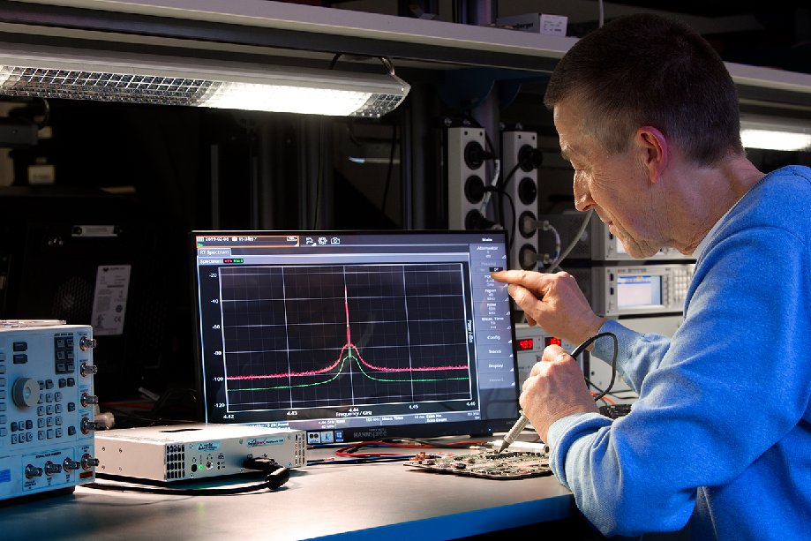Figure 1: The SignalShark family – high performance analyzers with top marks for dynamic range, sensitivity, and real time bandwidth. Its open platform philosophy means that it is highly flexible and can convincingly handle even sporadically occurring niche applications without compromise and without sacrificing performance thanks to the simple, user friendly integration of external supporting modules.

[02 narda signalshark open platform_200416.jpg]
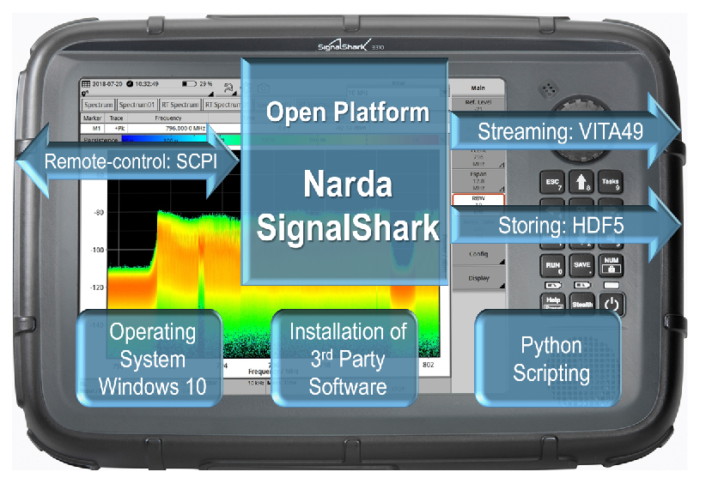
Figure 2: “Open platform” here means that the SignalShark family communicates in standard languages, and uses and supports the popular formats in common use in the scientific field.

Narda is a leading supplier of measuring equipment for RF Test & Measurement, EMF Safety and EMC. The RF Test & Measurement range includes analyzers and devices for the measurement and identification of RF sources. The EMF Safety product spectrum covers broadband and frequency-selective measuring devices, and EMF monitors for wide area coverage as well as personal safety monitors that can be worn on the body. The EMC sector offers instruments for determining the electromagnetic compatibility of devices under the PMM brand name. The range of services provided includes servicing, calibration, and training programs. The company operates a management system that complies with ISO 9001/2008 and ISO/IEC 17025.

Narda has development and production facilities in Pfullingen / Germany and Cisano / Italy, and has its own representative in Beijing / China. A worldwide network of representatives guarantees closeness to customers.

Narda is part of L3Harris Technologies.

For more information, contact:  Texterei Jungmann  [Press contact]  Thomas Jungmann  Bahnhofstr. 42  D-88239 Wangen im Allgäu  Tel.: +49 7522 9899 850  E-Mail: info@texterei-jungmann.de  http://texterei-jungmann.de | Narda Safety Test Solutions GmbH  Sandwiesenstr. 7  D-72793 Pfullingen  Tel.: +49 7121 97 32 0  Fax: +49 7121 97 32 790  E-Mail: info.narda-de@L3Harris.com  www.narda-sts.com

® Names and Logo are registered trademarks of Narda Safety Test Solutions GmbH and L3Harris Technologies, Inc. - Trade names are trademarks of the owners.

